

Soham Village College

Internal Exams Guide

2026 - 2027

Please visit the school website regularly for updated information and timetables:
Soham Village College - Internal Assessments and Mock Examinations

Updated October 2026
Internal Exams Guide
2026 - 2027
This guide to mock and internal exams contains a lot of useful information about how exams are run at SVC. Please read through it to make sure you understand what is expected of you during exams and how the exams are organised.

If you have any questions or queries about exams, please come and see me, Mrs Botcher, Exams Officer. My office is upstairs in Beechurst, next to the concrete stairs down to Beechurst Foyer, or you can send me an email: nbotcher@sohamvc.org

Timetables

If there are only one or two exams for your year group, information about these exams will be given via the student bulletin and your subject teachers.

If there are a number of exams scheduled for your year group over a period of a week or two weeks, you will be given a paper timetable via your Form Tutor about two weeks before the first scheduled exam.
Please remember you can also visit the school website for updated information and timetables:
Soham Village College - Internal Assessments and Mock Examinations

Exam rooms

Formal written exams are held in Beechurst Gym, Beechurst Hall, Beechurst Foyer, The Hub and B23.

Lining up on Beechurst playground

You must line up in your subject sets on Beechurst Playground (as per the diagram below) at least 10 minutes before the start of your exam. Listen carefully to all instructions. Your exam room, row number and name will be called out to ensure that everyone goes to the correct exam venue. If you don’t hear your name, wait until the end and ask.

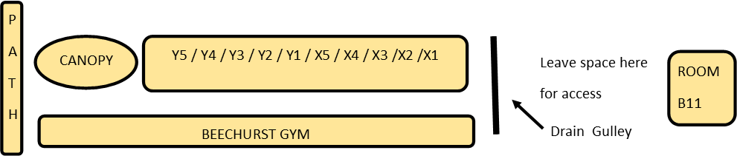
Behaviour and uniform

Excellent behaviour is expected from all students. You must listen carefully to all instructions given to you by exams staff and invigilators. Poor behaviour will not be tolerated and will be reported to your Head of Year. Correct uniform must be worn.

Remember you must always:
- Enter the exam room in silence
- Sit where you are told to and face the front. Do not talk or turn around.
- Do not look at the paper or write anything until instructed to do so.
- At the end of the exam, remain silent while the papers are collected.
- Leave the exam room in silence when instructed to do so - Please remember students may still be working.
- Do not talk to anyone until you have completely left the exam venue.

Equipment and water

You are responsible for bringing the correct equipment to all your exams. Put all your equipment in a clear plastic pencil case or clear bag. Equipment will not be loaned out.
Calculators are considered standard equipment - you will be told if you cannot use them. Do not bring calculator lids into an exam.
You may bring a bottle of water (not juice) into the exam room. Bottles must be transparent and without any labels.

Unauthorised items

We follow the same rules as for GCSE exams and for good practice you need to get used to these rules now. The following are all unauthorised items and must not be in brought into the exam room:

    - Mobile phones
    - AirPods/earbuds
    - Watches of any type
    - Smart glasses or any other smart devices
    - MP3/4 players or tablets
    - Notes / revision notes

You should leave unauthorised items in a safe place outside the exam room. Mobile phones and smart watches aren’t allowed in school. If you have a mobile phone, watch or any unauthorised items in your possession, you must hand them to an invigilator when told to do so. You can place items in a named plastic bag/wallet for easy identification at the end of the exam if you wish. Items are kept secure during the exam at the front of the exam room.

Bags and coats

If your exam is in Beechurst Gym, you will be told to leave your coat and bag in Beechurst boys’ changing room as you walk into your exam.
If your exam is in Beechurst Hall, Beechurst Foyer or B23, you will be told to leave your coat and bag in Beechurst girls’ changing room before you walk into your exam.
If your exam is in The Hub, please take your coat/bag with you and you will be told where you can leave it. If you do have a mobile phone in your possession, you will be required to hand it in to a member of staff for safe-keeping.

Help during an exam
Invigilators are in the exam room to ensure that everything runs smoothly and also to help you if you need something or don’t feel very well. Just put up your hand and someone will come to you. It’s important to ask for help if you need it.

Personal belongings left in the exam room

Any items left behind in the exam room are taken to the Finance Office for safe keeping. You may collect items from Finance during your break times or before or after school, not during lessons.

Absence from school on exam days

If you are unwell on the day of an exam, your parents must phone in your absence as normal. Once you are back at school, go and speak to the teacher of the exam you have missed to see what arrangements can be made.

Arriving late for an exam

Make every effort to be on time. If you do arrive late, sign in at Reception and explain you have an exam. I will be contacted and will see if I can still get you into the exam, depending on your arrival time.

Broken or sprained limbs

If you have an injury and cannot write or need extra room because you’ve hurt your leg, please let me or your Head of Year know straight away. Don’t wait until you are lining up for the exam as we may need to make extra arrangements for you.

Don’t forget, if you have any questions or queries about exams,
please come and see me, or send me an email: nbotcher@sohamvc.org
I wish you the best of luck for your exams!
Mrs Botcher
Exams Officer

