

**Soham Village College**

**Internal Exams**

**2021 to 2022**

Guidance for Students & Parents/Carers

**THINGS YOU SHOULD KNOW**

Please read and keep for future reference

This information is for YOUR benefit

Please regularly check the exams section on the school website for information about exams

Exam Rooms

Hello, my name is Mrs Everitt and I am the school’s Examinations Officer.

I work very hard to ensure that exam sessions run smoothly, however you also have a part to play and it is important that you understand what you need to do. I have put this leaflet together to help you and would like you to take just a few minutes to read through it.

REMEMBER if you have any queries about any aspect of exams, please come and speak to me. My office is upstairs in Beechurst near to rooms B4/B5.

**Mrs Everitt**

[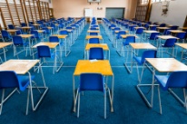](http://www.google.co.uk/url?sa=i&rct=j&q=&esrc=s&source=images&cd=&cad=rja&uact=8&ved=0ahUKEwjiqICjwLTPAhWMORoKHfZfC8wQjRwIBw&url=http://www.istockphoto.com/photo/empty-exam-desks-set-up-in-a-school-gym-gm477200516-67008581&bvm=bv.134495766,d.ZGg&psig=AFQjCNH0eUBYnZAvXKoHO-X5fsKggJ_DeA&ust=1475235916146648)

Formal written exams are held in Beechurst Gym, Beechurst Hall, Beechurst Foyer, The Hub and BM2.

Timetables

* If your year group has several exams in a session, then a paper timetable will be issued via your Form Tutor about 2 weeks before the first exam.
* If there are just 1 or 2 exams for your year group, information will only be given via the student bulletin, subject teachers and the school website.
* **Student Bulletin** – look out for exam information.
* **School Website** – Check the exams section for information.

[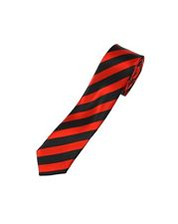](http://www.google.co.uk/url?sa=i&rct=j&q=&esrc=s&source=images&cd=&cad=rja&uact=8&ved=0ahUKEwjnu7qRxbTPAhVHkRQKHQvcCbUQjRwIBw&url=http://www.ebay.ie/sch/Fancy-Dress-Period-Costume-/163147/i.html?redirect%3Dmobile%26_nkw%3Dred%2Bties&psig=AFQjCNH9RFONnfRe2RbwKDv9jNC8pmZavQ&ust=1475237165892447)

Behaviour and Uniform

Excellent behaviour is expected from all students. You must listen carefully to all instructions given to you and act upon them. Poor behaviour will not be tolerated and sanctions may be given. Correct uniform must be worn.

Lining up in Beechurst Playground

Line up in your subject sets as per the diagram below. Listen carefully to all instructions to ensure that everyone goes to the correct room. If you are not sure, then wait until the end and ask.

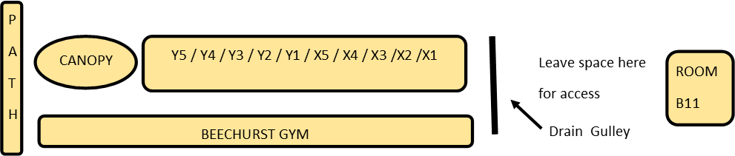

ROOM

B11

Drain Gulley

Leave space for others to cross between buildings

Y5 / Y4 / Y3 / Y2 / Y1 / X5 / X4 / X3 /X2 /X1

P

A

T

H

ROOM

B11

Drain Gulley

Leave space for others to cross between buildings

Y5 / Y4 / Y3 / Y2 / Y1 / X5 / X4 / X3 /X2 /X1

P

A

T

H

[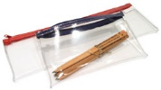](http://www.google.co.uk/url?sa=i&rct=j&q=&esrc=s&source=images&cd=&cad=rja&uact=8&ved=0ahUKEwiS49W6zbTPAhUDbhQKHXH7DdsQjRwIBw&url=http://www.greenandstone.com/v2/p/PAC.php?c%3D14%26d%3D162&bvm=bv.134495766,d.ZGg&psig=AFQjCNGndVaBrDhpyTRsNNWZnxndSyCvQA&ust=1475239414047776)Equipment / Water

Bringing the correct equipment to exams is YOUR responsibility. Put all your stationery equipment in a clear plastic pencil case/bag. Equipment will not be loaned out.

[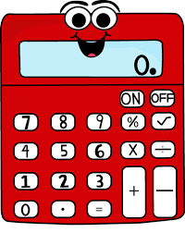](https://www.google.co.uk/imgres?imgurl=https://content.mycutegraphics.com/graphics/school/red-cartoon-calculator.png&imgrefurl=https://www.mycutegraphics.com/graphics/school/supplies/red-cartoon-calculator.html&docid=XyqAiiy3GxLpBM&tbnid=vtdlNE3P0ZNGvM:&vet=1&w=397&h=500&safe=strict&bih=1025&biw=1920&ved=0ahUKEwiD5Z3epdvdAhXSgVwKHS5UCTEQMwiBASgVMBU&iact=c&ictx=1)

Calculators are considered standard equipment, you will be told if you cannot use them. **DO NOT BRING CALCULATOR LIDS INTO EXAMS.**

**[](https://www.google.co.uk/url?sa=i&rct=j&q=&esrc=s&source=images&cd=&cad=rja&uact=8&ved=2ahUKEwibmdjnptvdAhUC0xoKHRr7Dx0QjRx6BAgBEAU&url=https://www.gograph.com/vector-clip-art/water-bottle.html&psig=AOvVaw1PHqJ2O6UGwaG4H2xTK2MA&ust=1538141762729599)**

Bottles of water (not juice) may be brought into exam rooms, but you must remove any labels beforehand.

[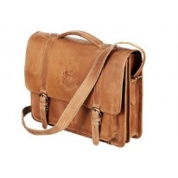](http://www.google.co.uk/url?sa=i&rct=j&q=&esrc=s&source=images&cd=&cad=rja&uact=8&ved=0ahUKEwjXp7HyzbTPAhWHHxoKHYCpDU0QjRwIBw&url=http://www.polyvore.com/velorbis_old_school_leather_satchel/thing?id%3D48593597&bvm=bv.134495766,d.ZGg&psig=AFQjCNHvG3RO537Iw9Tm5R_UNyLbuwC6rw&ust=1475239573339036)School Bags and Coats – if your exam is in …..

* Beechurst Gym - leave in Beechurst Boys’ Changing Room.
* Beechurst Hall - put on stage steps as directed by invigilators.
* Beechurst Stage – put at side as directed by invigilators.
* Beechurst Foyer - leave at the back of the Foyer.
* BM2 - leave at back of room or where the invigilator ask you to do so.

Help During Exam

[](http://www.google.co.uk/url?sa=i&rct=j&q=&esrc=s&source=images&cd=&cad=rja&uact=8&ved=0ahUKEwjpzbqDz7TPAhUIGhQKHfVICYgQjRwIBw&url=http://clipart.me/premium-education/silhouettes-of-elementary-school-children-holding-hands-251057&bvm=bv.134495766,d.ZGg&psig=AFQjCNFCquvwrq7VjTzC2JNH_VsWB4a9_g&ust=1475239831937253)Invigilators are in the exam room to ensure that everything runs smoothly, but also to help you if you require something or don’t feel very well. Just put up your hand and someone will come to help. Please don’t worry about anything, just ask and we will do our best to help you, we don’t want you to sit in silence worrying.

[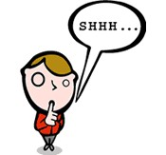](http://www.google.co.uk/url?sa=i&rct=j&q=&esrc=s&source=images&cd=&ved=0ahUKEwjHr9TYz7TPAhUNnRQKHXbyCrIQjRwIBw&url=http://www.clipartkid.com/shush-cliparts/&bvm=bv.134495766,d.ZGg&psig=AFQjCNEw-4CpJCvZp9ZGiO5ig2l_mp8aqw&ust=1475240006357217)Your time in the exam room

* Enter in silence.
* Sit where directed, face the front, do not talk or turn around.
* Put up your hand if you have a question.
* At the end of the exam – sit silently whilst papers are collected.
* Do not talk to your friends until you are completely out of the exam room.
* Leave quietly and in silence when told to do so.

Some students have extra time and may still be working when you are finished, please be respectful, it is unfair to disrupt their exam.

[](https://www.google.co.uk/url?sa=i&rct=j&q=&esrc=s&source=images&cd=&cad=rja&uact=8&ved=0ahUKEwi30Mv049vWAhVLVRoKHXpSDpkQjRwIBw&url=https://www.dreamstime.com/illustration/wristwatch.html&psig=AOvVaw3bLvCUeC7xSg64c5Kan4lA&ust=1507371815563909)[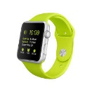](https://www.google.co.uk/imgres?imgurl=https://smarter.telstra.com.au/content/smarter/genericarticles/technology/the-highly-speculated-apple-watch-is-here/_jcr_content/genarticlepar2/imageandtextwrap/image.img.jpg/1413680023966.jpg&imgrefurl=https://smarter.telstra.com.au/the-highly-speculated-apple-watch-is-here&docid=sG-cDz8xGbEL4M&tbnid=sgXVVdiIYabffM:&w=600&h=600&safe=strict&bih=961&biw=1920&ved=0ahUKEwjGhIXN0bTPAhUrDMAKHRNLDBM4ZBAzCE8oTTBN&iact=mrc&uact=8)[](https://www.google.co.uk/url?sa=i&rct=j&q=&esrc=s&source=images&cd=&cad=rja&uact=8&ved=0ahUKEwjS1cCr0bTPAhUHNxQKHU2eCbcQjRwIBw&url=https://www.olloclip.com/&psig=AFQjCNEcC9Dzc5EvRxAt2Qr6WaH7zSrzWA&ust=1475240508252720)Unauthorised material

For GCSE exams mobile phones, watches (including ordinary wrist watches) and any other technological/web enabled source of information are considered unauthorised items. If you are found in possession of any of these items it is considered to be a serious offence and could result in DISQUALIFICATION.

For good practice you need to get used to this now. These regulations will apply for internal/mock exams. Don’t risk a sanction by ignoring this advice.

If at all possible leave unauthorised items in a safe place outside the exam room. If this isn’t possible you will need to hand them to an invigilator when asked. You should provide your own sealed and named plastic bag for easy and secure identification as all items will be placed in a box for the duration of the exam.

Left something in the exam room?

[](http://www.google.co.uk/url?sa=i&rct=j&q=&esrc=s&source=images&cd=&cad=rja&uact=8&ved=0ahUKEwj4o9TH1LTPAhVE1xQKHYEcB2IQjRwIBw&url=http://eliotbank.lewisham.sch.uk/2014/10/lost-and-foun/&bvm=bv.134495766,d.ZGg&psig=AFQjCNGAK1jVjs4lgS_pgtayK_sjErZa1w&ust=1475241211797090)

Any Items left behind after the exam are taken to the FINANCE OFFICE after the exam for safe keeping. You may collect items from Finance during your break times or before or after school, not during lessons.

Absent from school on the exam day?

[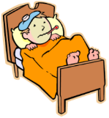](https://www.google.co.uk/url?sa=i&rct=j&q=&esrc=s&source=images&cd=&cad=rja&uact=8&ved=0ahUKEwiZks6y1bTPAhXHuBoKHZu6BWcQjRwIBw&url=https://www.sandiegounified.org/schools/rosa-parks/student-health&bvm=bv.134495766,d.ZGg&psig=AFQjCNHjUGLzu7bUAsxzdmCV58dm0eptlw&ust=1475241601601200)If you aren’t well on the day, your parents must phone in your absence as normal. Once you are back at school, go and speak to the teacher of the exam you have missed to see what arrangements can be made.

Late arrival

[](http://www.google.co.uk/imgres?imgurl=http://www.clipartbest.com/cliparts/eTM/dAX/eTMdAXGXc.png&imgrefurl=http://www.clipartbest.com/late-clip-art&h=209&w=205&tbnid=DVDEj_Fja2NS3M:&zoom=1&q=free%20clip%20art%20someone%20late&docid=WoSijCE6oMd49M&ei=3iQgVLKSO8XiasiIgPgO&tbm=isch&ved=0CFEQMyglMCU&iact=rc&uact=3&dur=2691&page=1&start=0&ndsp=52)Make every effort to be on time, but if you do arrive late sign in at Student Services and tell them that you have an exam. They will contact me and I will see if I can still accommodate you in the exam.

[](http://www.google.co.uk/url?sa=i&rct=j&q=&esrc=s&source=images&cd=&cad=rja&uact=8&ved=0CAcQjRxqFQoTCMbFz-unv8gCFQu3FAodpogOBQ&url=http://www.cliparthut.com/christ-open-arms-clipart.html&psig=AFQjCNFL3LwiRWMuiHjzVfVehKl5xT9Fow&ust=1444820974935355)Broken/Sprained Limbs

If you’ve injured yourself and can’t write or need extra room if you’ve hurt your leg, please make sure I am informed asap. DON’T wait until you are lining up for the exam. If you can’t find me, please speak to your Year Head.

***Please come and speak to me in good time if you have any questions at all about your exams***

***Mrs Everitt / Examinations Officer***